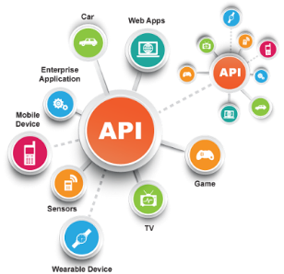**SE495 Software and Systems Integration**

**Building a Simple Middleware Integration System**

**Overview**

In this guided project, students will learn to apply the concepts from the "Middleware Technologies for Systems Integration" chapter by building a simple middleware integration system. The project will involve creating a message-oriented middleware (MOM) system, implementing an enterprise service bus (ESB), and using an integration platform as a service (iPaaS) to connect different components of a distributed application.

**Learning Objectives**

1. Understand the role of middleware in systems integration
2. Implement a basic message-oriented middleware (MOM) system
3. Utilize an enterprise service bus (ESB) for message routing and transformation
4. Leverage an iPaaS solution to integrate components of a distributed application
5. Compare the benefits and drawbacks of different middleware technologies

**Project Structure**

**Part 1: Introduction to Middleware and Message-Oriented Middleware (MOM)**

1. Students will learn the basics of middleware and its role in systems integration.
2. Students will create a simple message broker using Python and RabbitMQ as a message-oriented middleware (MOM) example.
3. Implement a publisher and subscriber system to demonstrate the communication between components through the message broker.

**Part 2: Enterprise Service Bus (ESB)**

1. Students will learn the concept of an enterprise service bus (ESB) and its role in middleware integration.
2. Utilize an open-source ESB solution (e.g., Mule ESB or Apache Camel) to set up a basic ESB for message routing and transformation.
3. Modify the publisher and subscriber system from Part 1 to communicate through the ESB instead of directly through the message broker.

**Part 3: Integration Platform as a Service (iPaaS)**

1. Students will learn about iPaaS and the benefits of using a cloud-based integration platform.
2. Select an iPaaS solution (e.g., Zapier or MuleSoft) and create an account for the trial version.
3. Create a simple integration scenario using the iPaaS solution to connect a public API (e.g., weather data) to a notification service (e.g., email or Slack).

**Part 4: Comparison and Use Cases**

1. Students will discuss the benefits and drawbacks of each middleware technology (MOM, ESB, and iPaaS) based on their experiences implementing the guided project.
2. Analyze different scenarios and choose the appropriate middleware technology for each case.
3. Prepare a short presentation or report summarizing their findings and recommendations.

**Additional Resources**

* [RabbitMQ tutorials](https://www.rabbitmq.com/getstarted.html)
* [MuleSoft ESB documentation](https://docs.mulesoft.com/mule-runtime/4.3/)
* [Apache Camel documentation](https://camel.apache.org/manual/latest/)
* [Zapier documentation](https://zapier.com/learn/)
* [MuleSoft Anypoint Platform documentation](https://docs.mulesoft.com/platform/)